Experiment Number: 01
Title: Setting up small wired and wireless computer networks and hands on networking commands

OBJECTIVES:
To learn how to setup a wired and wireless network and understand working of various internetworking devices

To learn the network commands

PROBLEM STATEMENT
1a) Setting up small wired computer network:
Set up a small wired network of 2 to 4 computers using Hub/Switch/. It includes Preparation of Cables and setting up wired network.

1b) Setting up small wireless computer network and hands-on networking command:
Set up a small wired network of 2 to 4 computers using access point and ask students to access it on their wireless gadgets.

Hands on for network commands - ping, pathping, ipconfig/ifconfig, arp, netstat, nbtstat, nslookup, route, traceroute/tracert, nmap.

THEORY: TYPES OF NETWORK
Common examples of area network types are:
Local Area Network (LAN):
LAN is privately owned networks use to interconnect computers within a single building or campus up to few kilometers in size. For the LAN, diameters spans over 550 meters to 2.5 Kilometers. Nowadays organizations have Campus Wide Network which is an extension of LAN using OFC at backbone and diameter IS up to 10 Kilometers. LANs are setup using IEEE802.3 standard. (Active).
Wide Area Network (WAN):
WAN is a telecommunication or computer network span over the area often country or continent. WAN: 100km to 1000 km Country and Continent. Uses Packet Switching and Data Switching Exchanges. Uses IEEE 802.1 standard.

Personal Area Network (PAN):
PAN is the interconnection of mobile devices within the range of an individual person. typically within a range of 10 meters. PAN : 10 meters. Uses IEEE 802.15 standard (Active).
Internet:
The Internet is the global system of interconnected computer networks that use the Internet protocol suite (TCP/IP) to link devices worldwide. Internet is WAN hence covers Country, Continent or entire planet. Uses Packet Switching and networks are connected by routers.

Internetwork:
Connecting homogeneous or heterogeneous LAN and MAN to extend network reach. Uses IEEE 802 standards. It covers LAN/MAN architecture, internetworking among 802 LANs, MANs and wide area networks, 802 Link Security and 802 overall network management

Network Architectures:
Client – Server:
Server: Powerful (High End) machine consisting databases, applications, Internet Protocol servers (Blade Server) at central place. Client: Employee having low end machine to access the information.
Peer to Peer Network:
A network of computers configured to allow certain files and folders to be shared with everyone or with selected users. Peer-to-peer networks are quite common in small offices that do not use a dedicated file server.

Distributed Network (DN):
Distributed network is a distributed computing network system in which computer programming functionality and the data to be worked on are spread out across more than one computer. Usually, this is implemented over a computer network.
Software Defined Networking (SDN): Software-defined networking (SDN) technology is an approach to computer networking that allows network administrators to programmatically initialize, control, change, and manage network behavior dynamically via open interfaces and abstraction of lower-level functionality.

Infrastructure network:
Infrastructure mode supports central connection points for clients. An Infrastructure mode network requires the use of an Access Point. The Access Point controls Wireless communication and offers several important advantages over an Ad-hoc network. For example, a Infrastructure based network supports increased levels of security, potentially faster data transmission speeds and integration with a wired network.

Ad-hoc network:
An Ad-hoc network allows each device to communicate directly with each other. There is no central Access Point controlling device communication. Ad-hoc networks are only able to communicate with other Ad-hoc devices, they are not able to communicate with any Infrastructure devices or any other devices connected to a wired network. In addition, Ad-hoc mode security is less sophisticated compared to an Infrastructure mode.

IEEE 802 standards covers only LAN, MAN, WAN, SAN, ISDN and Wireless
Internetworking  :LLC  :Ethernet  :Token Bus x  :Token Ring x  :MAN  :Broadband  :Fiber Optics  :ISDN | : Network Security  : WLAN, Wi-FI  : 100VG - Any LAN  :  : Cable Modem  802.15.2 : Bluetooth  802.15.4 : WSN, ZigBee  : Wi-MAX, WMAN  : Resilient packet ring | :Radio Regulatory TAG  :Coexistance TAG  : Mobile Broadband  : Media Independent Handoff  : Wireless Regional Area Networks  802.25 : Omni-Range Area  Network
TYPES OF CABLES

Unshielded Twisted Pair (UTP) Cable
Twisted pair cabling comes in two varieties: shielded and unshielded. Unshielded twisted pair (UTP) is the most popular and is generally the best option for school networks
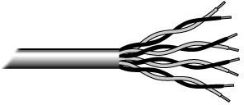
Fig.1. Unshielded twisted pair

The quality of UTP may vary from telephone-grade wire to extremely high-speed cable. The cable has four pairs of wires inside the jacket. Each pair is twisted with a different number of twists per inch to help eliminate interference from adjacent pairs and other electrical devices. The tighter the twisting, the higher the supported transmission rate and the greater the cost per foot. The EIA/TIA (Electronic Industry Association/Telecommunication Industry Association) has established standards of UTP and rated six categories of wire (additional categories are emerging).

Standards for Rating UTP Cable
Category 1 (CAT-1) --For analog and digital voice (telephone) and low-speed data applications ( Being used nowadays for telephone network only)
Category 2 (CAT-2) --For voice, Integrated Services Digital Network (ISDN), and medium-speed data up to 4 Mbps. (obsolete )
Category 3 (CAT-3) --For high-speed data and LAN traffic up to 16 Mbps ( Used nowadays for Alarm Control Mechanisms in Apartments and Industry)

Category 4 (CAT-4) --For long-distance LAN traffic up to 20 Mbps (obsolete)
Category 5 (CAT-5) --For 100-Mbps LAN technologies such as 100-Mbps Ethernet over 100 MHz (Older LAN Standard. obsolete)
Category 5e (CAT-5e) --Enhanced category 5 provides for full duplex Fast Ethernet support (used nowadays) with 1 Gbps upto 100 meters. Frequency 100 and 250 MHz.
Category 6 (CAT-6) – 10 Gbps up to 164 feet 50/55 meters— anything beyond that will rapidly decay to only 1 Gigabit (the same as Cat5E). Frequency 350 MHz
Category 6a (CAT-6a) -- 10 Gigabit speeds for the full 328 feet of Ethernet cable. Frequency 550 MHz.

Category 7 (CAT-7) -- The maximum allowed length of a Cat-6 cable is 100 meters (330 ft) when used for 10/100/1000baseT and 55 meters (180 ft) when used for 10GbaseT. Frequency 600 MHz.

Higher category UTP cables are made from higher quality materials.
Each higher category is also made with tighter cable twists for increased resistance to interference
Fiber Optic Cable
A fiber optic cable is a thin strand of glass or plastic, coated with a protective plastic jacket. It is so thin that even the glass fibers bend easily.
A beam of light can be trapped within a fiber, so that the optical cable essentially becomes a pipe that carries light around corners. An optical fiber can carry a light signal for a long distance typically up to 2 km.
Because light is not appreciably affected by electromagnetic fields, optical signals are immune to EMI/RFI. This makes fiber a good choice for "noisy" environments with many electrical motors, such as elevator shafts and factories.
Because fiber does not corrode, it is well suited for high-humidity and underwater environments. Optical fiber is also a highly secure medium, because it is difficult to splice (cannot flow) into a fiber optic cable without detection.
The primary disadvantage of fiber optic cable is its cost. Fiber optic cable and equipment are relatively expensive in terms of both materials cost and installation.
However, industries that need the high capacity and secure features of fiber find it well worth the investment. For example, nearly all long-distance telecommunication lines are fiber optic.
Fiber Communication System
The basic model for a communication system includes a transmitter and receiver, connected by optical fiber cabling.
In typical fiber optic systems, each device contains both a transmitter and receiver, combined in a single transceiver unit.
Because fiber optic cable must be cut to present the light beam to a receiver, only point-to-point connections can be made; a bus cannot be constructed

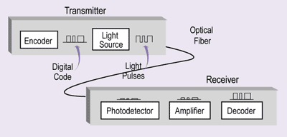Transmitter
Encoder that converts the input data signal into digital electrical pulses
Light source that converts the digital electrical signal to light pulses
Connector that couples the light source to the fiber through which the light rays travel
The transmitter accepts digital electrical signals from a computer.
A diode converts the digital code into a pattern of light pulses that are sent out to the receiver through the optical fiber.
Light emitting diodes (LEDs) use less power and are considerably less expensive than lasers. LEDs can be used with multimode cable, and are the most common light source. LEDs provide a bandwidth of approximately 250MHz .
Laser diodes are used with single-mode fiber for long-distance transmission. Laser light is more powerful because laser light waves are radiated in phase, which means the crests(H-peak) and troughs( L-peak) of all light waves are perfectly aligned with one another. This alignment or coherence creates a signal with much less attenuation and dispersion than noncoherent light. Laser diodes can provide much higher bandwidth 10 GHz.
Frequency Range : 250 MHz to 10 GHz Receiver
A receiver converts the modulated light pulses back to electrical signals and decodes them. The receiver, contained within the destination computer system, includes:
Photo detector that converts the light pulses into electric signals
Amplifier, if needed
Message decoder
WARNING:
Never look into a fiber optic cable to see whether light is present. The infrared laser light used in fiber optic LANs is invisible; however, it can permanently damage your eyesight in an instant.
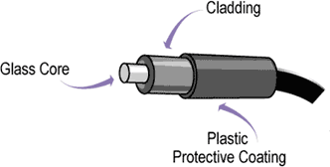

Core--A solid fiber of highly refractive clear glass or plastic that serves as the central conduit for light.
Cladding--A layer of clear glass or plastic with a lower index of refraction. When light traveling down the core reaches the boundary between the core and cladding, the change in refractive index causes the light to completely refract or bend back into the core. The cladding of each fiber completely contains light signals within each core, preventing crosstalk. This effect is called "total internal reflection.‖
Coating--A reinforced plastic outer jacket that protects the cable from damage. Dimensions ( Diameter)
Fiber optic cable is very thin. The diameters of fiber optic cores and cladding are specified in µm. The thinnest fiber optic cable (single-mode) typically has a core diameter of 5 to 10 µm I.e.
0.005 to 0.010 mm. Thicker fiber optic cable (multimode) ranges from 50 to 100 µm in core diameter. In comparison, human hair is approximately 100 µm thick.
Fiber optic cable is specified in terms of its core and cladding diameter. For example, the most common type of fiber optic cable for LAN installations is 62.5/125-m cable, where 62.5 refers to the core diameter and 125 refers to the cladding diameter.
The core diameter is also known as the aperture, because it determines the maximum angle from which the cable can accept light. Total internal reflection only occurs when light strikes the cladding at a shallow angle. If the angle is too steep, some or all of the light will penetrate the cladding itself, causing signal loss.
Each fiber optic core conducts light in one direction only. Therefore, to send and receive, devices are usually connected by two fiber optic strands. These may be single strand simplex cables, or duplex cables containing two fiber optic strands. Duplex cables are more commonly used than simplex cables.
Fiber cables can also consist of several bundles. These are used for high-capacity backbones for outdoor connections between campus buildings. Because light signals are completely contained within each fiber, no coating or shielding is necessary between fibers. However, reinforcing strands are usually added to increase the pulling strength of the cable.
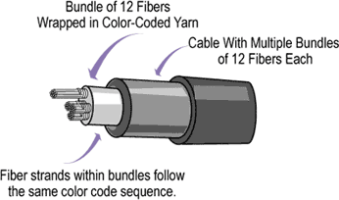
FOC General Types
Multimode fiber is wide enough to carry more than one light signal. Each signal is called a "mode.‖
Single-mode fiber is thin and can carry only one light signal.

Multimode Fiber
Each light signal or light ray that passes through a cable is called a "mode." Multimode fiber optic cable is wider than single-mode cable, thus it has enough room for more than one light ray. These light signals are separated by different angles of reflection as they travel down the core.
Because multimode signaling separates light signals by angle, not all light rays travel the same distance. Some light rays will travel nearly straight through the core, while others bounce off the cladding many times before reaching the far end of the fiber.
With modes traveling different distances, but at the same speed, the spread of the signal increases over time, and can cause data errors due to the overlapping of light pulses. This problem is known as modal dispersion. The construction of a multimode fiber can either cause or fix this problem.
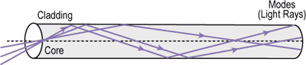
Types of multimode fiber
Step-Index Fiber
The standard type of optical fiber, called "step-index fiber", consists of only two transparent layers (core and cladding), and index of refraction is same.
Graded-Index Fiber
The core of a graded-index fiber cable has several transparent layers, each with a different refractive index. This planned inconsistency allows light modes to travel at different speeds through the core. The speed at which the modes travel depends upon the part of the core it is traveling through. Modes traveling down the center of the core do so at a slower speed than those refracting off the cladding.

Single Mode Fiber
Single-mode fibers have diameters sized to the wavelength they are designed to carry. A typical single-mode fiber core diameter is 8 µm. Only one mode will propagate through fiber with this core diameter. The narrower fiber diameter causes a light signal to travel in a straighter path, with less reflection and dispersion. However, the narrower core also makes single-mode fiber more difficult and expensive to install.
Single-mode fibers require laser diode transmitters. By using this coherent light source, single- mode fiber optic cable can support longer transmission distances than multimode fiber. Distances range from a few miles to as many as 20 miles.
Fiber optic cable is difficult to install correctly; therefore, it requires well-trained, careful installation technicians. This, combined with the time-consuming nature of each connection, make fiber optic cable the most expensive cable to install. Because of this need for training and experience, many organizations hire specialists to install fiber optic networks.
Connections and splices of fiber optic cable are particularly difficult to make. Each end of the cable must be cut off at perfect right angles, the ends polished by hand or machine, and the cable precisely aligned to the connector.
Single-mode fibers are generally step-index fibers. Because only one mode travels along the fiber, the problem of diffusion does not occur in single-mode fibers.

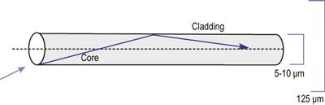
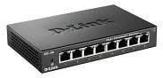

Optical Carrier Levels: OC-n

Optical Carrier Level Data Rate
OC-1 51.84 Mbps
OC-3 155.52 Mbps
OC-12 622.08 Mbps
OC-24 1.244 Gbps
OC-48 2.488 Gbps
OC-192 10 Gbps
OC-256 13.271 Gbps
OC-768 40 Gbps

What do the fiber terms 9/125, 50/125 and 62.5/125 refer to?
The first set of numbers - 9, 50 and 62.5 refer to the diameter of the fiber cable's core. The second set of numbers - 125 refer to the diameter of the outside of the fiber cable's cladding. The cladding is a special coating that keeps the light from escaping the glass core. 9/125 refers to a single mode fiber cable. 50/125 and 62.5/125 refer to multimode fiber cable

1a) We setup the network using 2 ways – wired connection and wireless connection. In wired mode, we connect 2 laptops/desktops via a hub/switch. This consisted of connecting the Ethernet ports of the laptop/desktop to the hub/switch and then modify the network settings in the control panel.

Cable Preparation:
There are generally three main types of networking cables: straight-through, crossover, and rollover cables. Each cable type has a distinct use, and should not be used in place of another. So how do you know which cable to use for what you need?
The Purpose of Straight-Through Cables
Straight-through cables get their name from how they are made. Out of the 8 pins that exist on both ends of an Ethernet cable, each pin connects to the same pin on the opposite side. Review the diagram below for a visual example:

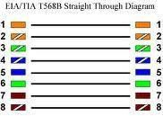
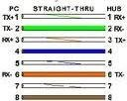

OR

Notice how each wire corresponds to the same pin. This kind of wiring diagram is part of the
568A standard. The 568B standard achieves the same thing, but through different wiring. It is generally accepted to use the 568A standard as pictured, since it allows compatibility with certain telephone hardware- while 568B doesn’t.
Straight-through cables are primarily used for connecting unlike devices. A straight-through cable is typically used in the following situations:
Use a straight-through cable when:

Connecting a router to a hub
Connecting a computer to a swtich
Connecting a LAN port to a switch, hub, or computer
Note that some devices such as routers will have advanced circuitry, which enables them to use both crossover and straight-through cables. In general, however, straight-through cables
will not connect a computer and router because they are not ―unlike devices.‖

The purpose of Crossover Cables

Crossover cables are very similar to straight-through cables, except that they have pairs of wires that crisscross. This allows for two devices to communicate at the same time. Unlike straight-through cables, we use crossover cables to connect like devices. A visual example can be seen below:

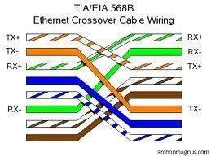
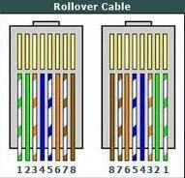

Notice how all we did was switch the orange-white and green-white wires, and then the orange and green wires. This will enable like devices to communicate. Crossover cables are typically used in the following situations:
Use a crossover cable when:

Connecting a computer to a router
Connecting a computer to a computer
Connecting a router to a router
Connecting a switch to a switch
Connecting a hub to a hub

While the rule of thumb is to use crossover cables with like devices, some devices do not follow standards. Others provide support for both types of cables. However, there is still something that both crossover and straight-through cables can’t do.
The Purpose of Rollover Cables

Rollover cables, like other cabling types, got their name from how they are wired. Rollover cables essentially have one end of the cable wired exactly opposite from the other. This essentially ―rolls over‖ the wires- but why would we need to do such a thing? Rollover cables, also called Yost cables, usually connect a device to a router or switch’s console port. This allows a programmer to make a connection to the router or switch, and program it as needed. A visual example can be seen below:

Notice that each wire is simply ―rolled over.‖ These types of cables are generally not used very much, so are usually colored differently from other types of cables.

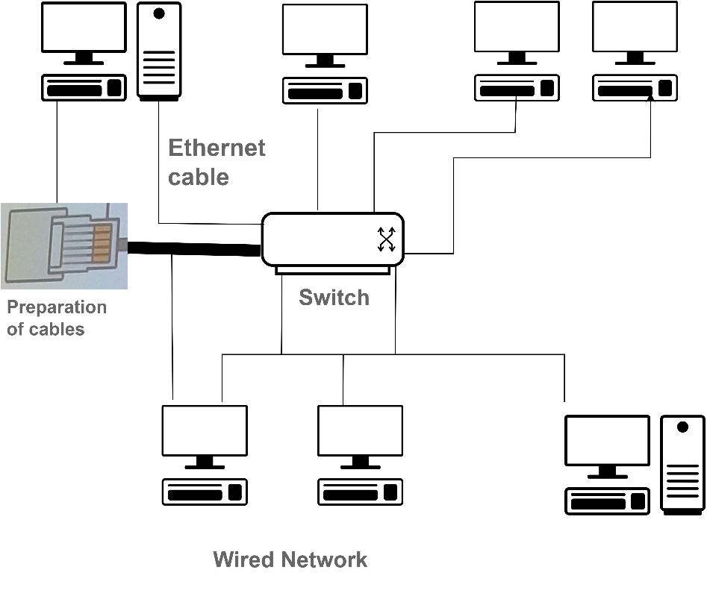

1B) 1b) Wi-Fi setup Procedure

In the wireless connection mode, we setup the router or the access point first using the provided instruction guidelines. Following is the procedure to configure Wi-Fi network.

Wi-Fi setup
Step 1: connect router to internet using yellow color port. Step2: connect your laptop/ desktop by using non yellow port. Step3: configure your desktop for DHCP .
Step 4: access the router using www.routerlogin.net.

Step 5 : configure basic screen using internet option for IP credentials of desktop.

Step 6: access the internet through browser using 172.16…..access control of VIT

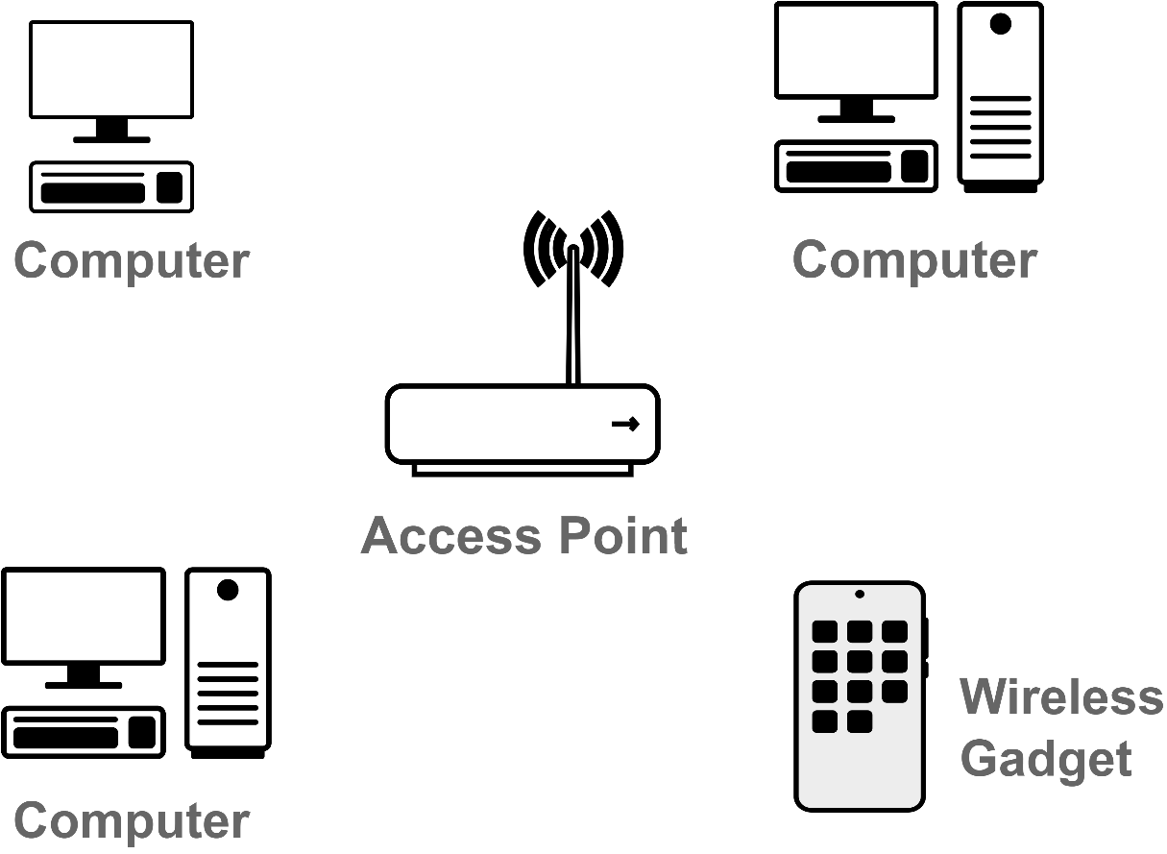

1c) Network Commands:
Ping command:
Ping is a computer network administration software utility used to test their reachability of a host on an Internet Protocol network.

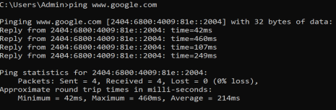

Pathping command: The PathPing command is a command-line network utility supplied in Windows2000 andbeyond that combines the functionality of ping with that of tracer

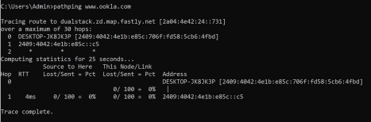

ipconfig command:
The ipconfig command, which displays all current TCP/IP networkconfiguration values.
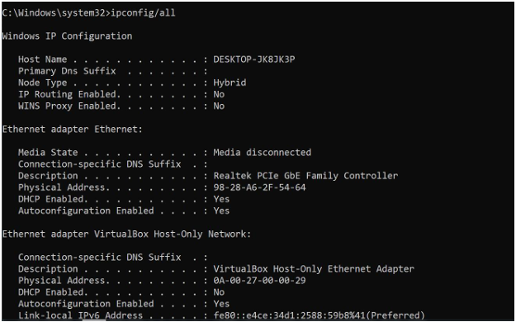

arp command :The arp command displays and modifies the Internet-to-adapter address translation tables used by the Address in Networks and communication management. The arp command displays the current ARP entry for the host specified by the Hostname variable.

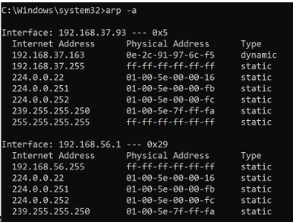

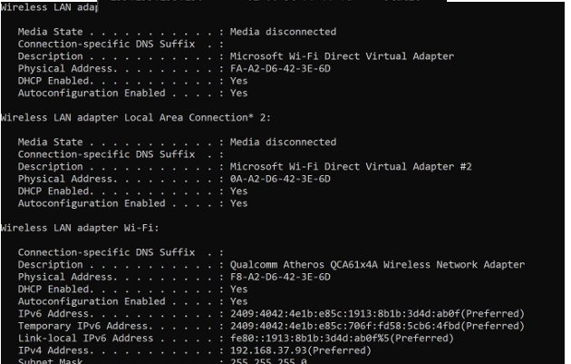

nslookup command: Nslookup (stands for ―Name Server Lookup‖) is a useful command for getting information from the DNS server. It is a network administration toolfor querying the Domain Name System (DNS) to obtain domain name or IP address mapping or any other specific DNS record. It is also used to troubleshoot DNS-related problems.

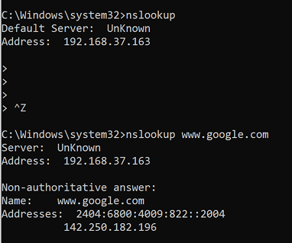

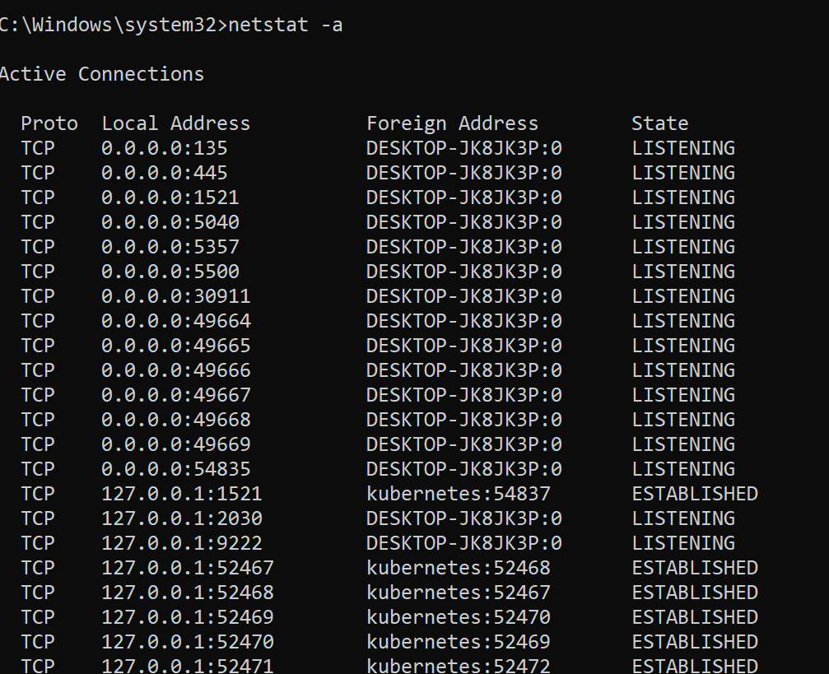
netstat command : Netstat command displays various network related information such as network connections, routing tables, interface statistics, masquerade connections, multicast memberships etc.,

route command :The route command allows you to make manual entries into the network routing tables.The route command distinguishes between routes to hosts and routes to networks by interpreting the network address of the Destination variable, which can be specified either bysymbolic name or numeric address.

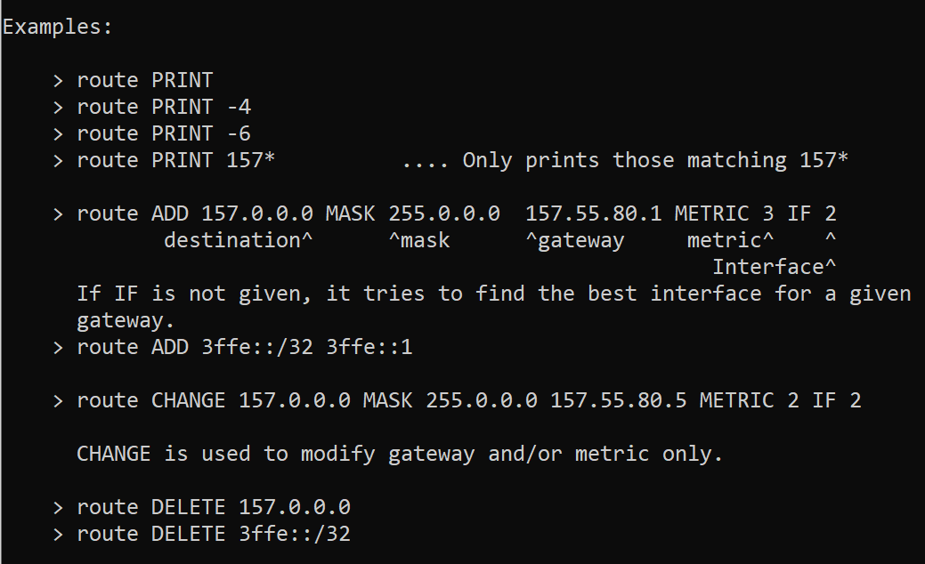

tracert command :The traceroute command is used to determine the path between two connections. Often a connection to another device will have to go through multiple routers. The traceroute command will return the names or IP addressesof all the routers between two devices.

-h:

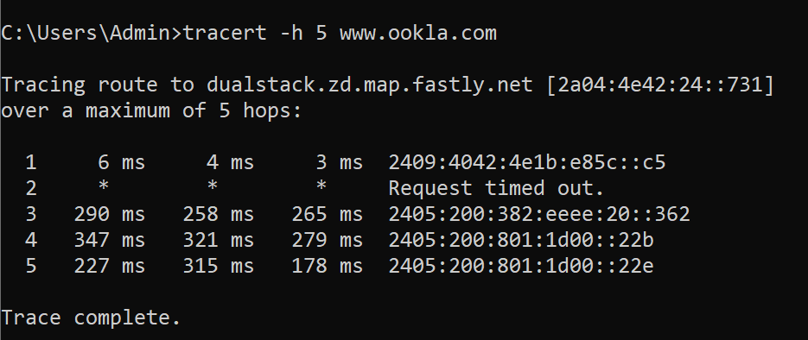

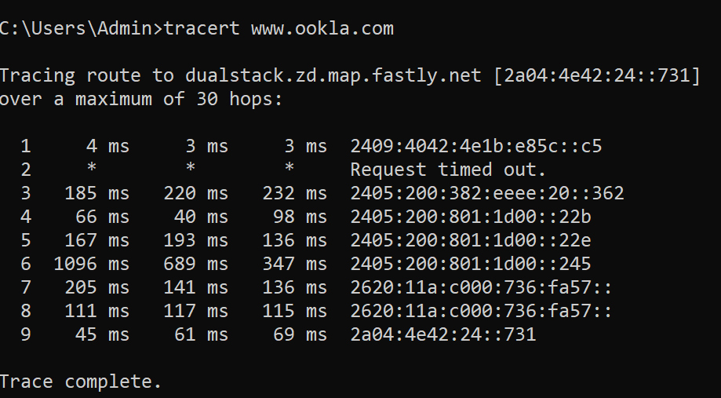
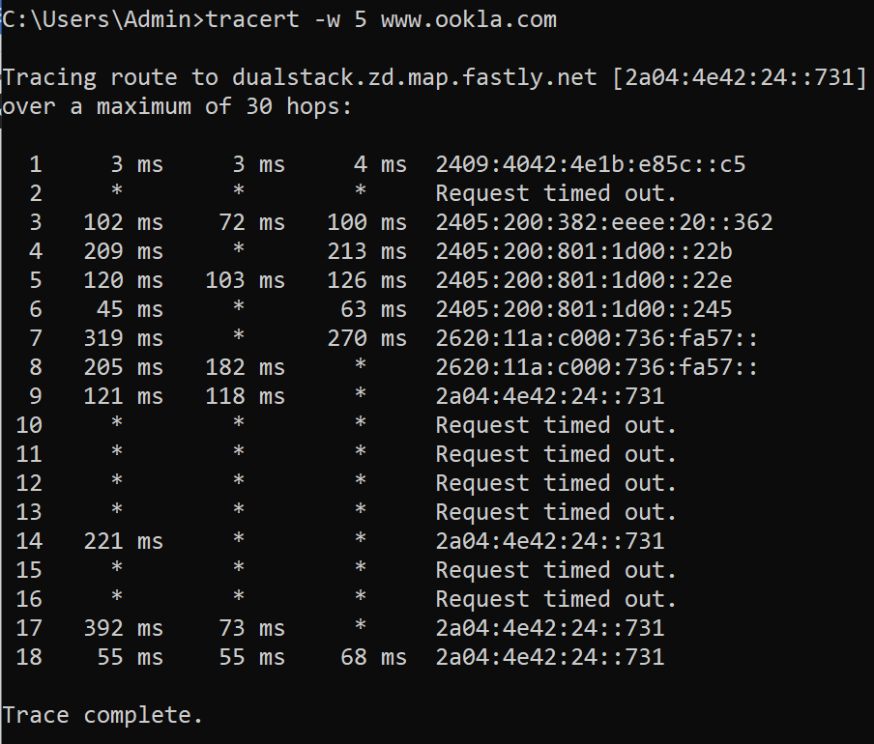
-d:
